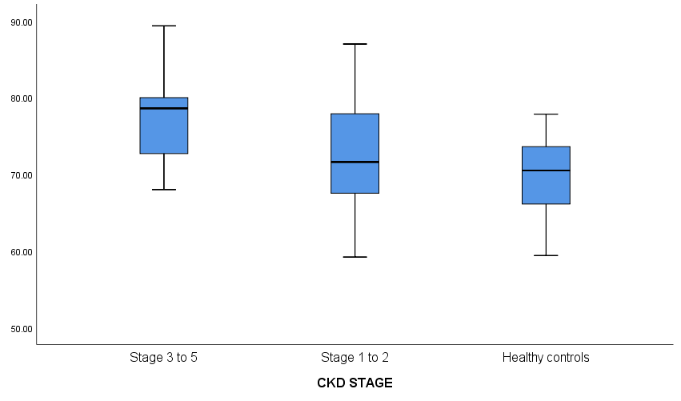

Enterrobacteriaceae DNA / ng/µL

70.5 [72.1-73.6]

71.6 [65.7-77.9]]

78.6 [72.7-80.0]

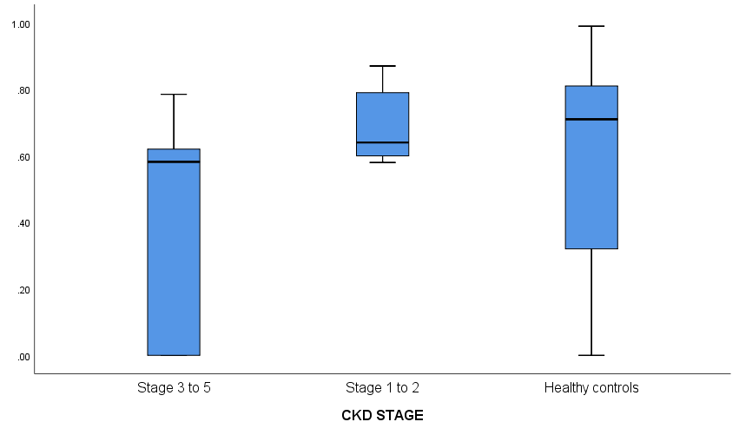

0.64 [0.60-0.79]

0.71 [0.32-0.81]

0.58 [0.00-0.62]

*Lactobacillus* DNA / ng/µL

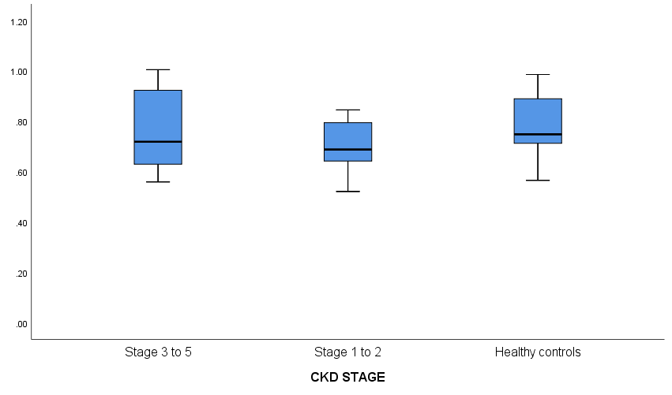

0.72 [0.63-0.92]

0.69 [0.64-0.79]

0.75 [0.71-0.89]

*Bifidobacterium* DNA / ng/µL